|  |
| --- |
| FIXCODE |
| Buggy code |
| Fiza Batool  153159  BSCS-V |

Buggy code

# Given code:

// Read code below and try to identify any bug and then fix it.

|  |
| --- |
|  |
| int main() |
|  | { |
|  | cout << "This program will crash" |
|  | << endl; |
|  |  |
|  | int nSum; |
|  | int nNums; |
|  |  |
|  | // accumulate input numbers until the |
|  | // user enteres a negative number, then |
|  | // return the average |
|  | nNums = 0; |
|  | while(true) |
|  | { |
|  | // enter another number to add |
|  | int nValue; |
|  | cout << "Enter another number:"; |
|  | cin >> nValue; |
|  | cout << endl; |
|  |  |
|  | // if the input number is negative... |
|  | if(nValue < 0) |
|  | { |
|  | // ... then output the average |
|  | cout << "Average is: " |
|  | << nSum/nNums |
|  | << endl; |
|  | break; |
|  | } |
|  |  |
|  | // not negative, add the value to |
|  | // the accumulator |
|  | nSum += nValue; |
|  | } |
|  |  |
|  | cin.ignore(10000, '\n'); |
|  | return 0; |
|  | } |
|  |  |

# Correction #1:

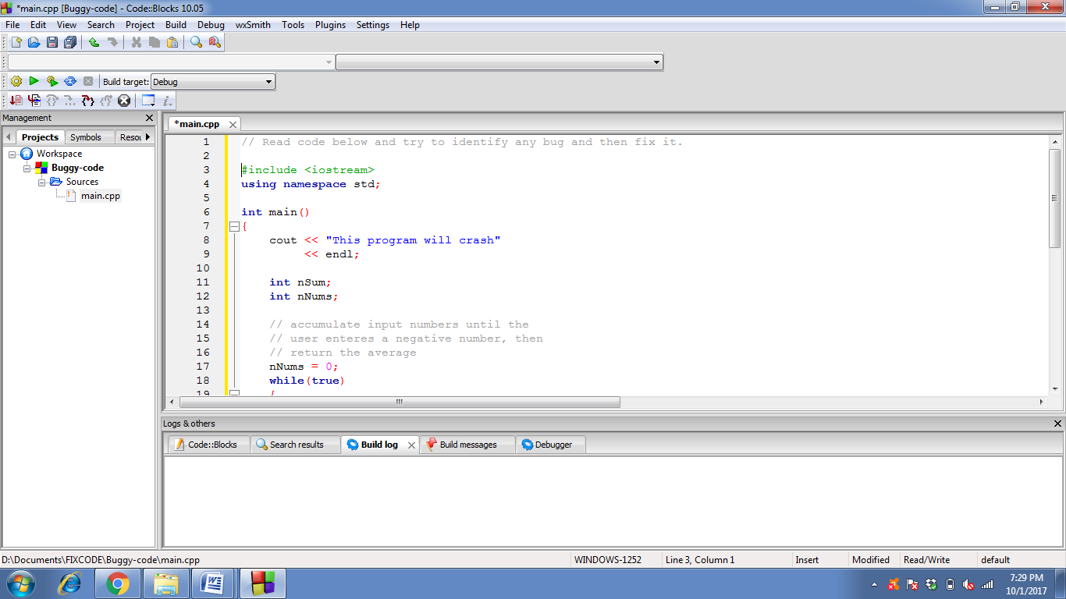

Header files for important input and output commands.

# Correction #2:

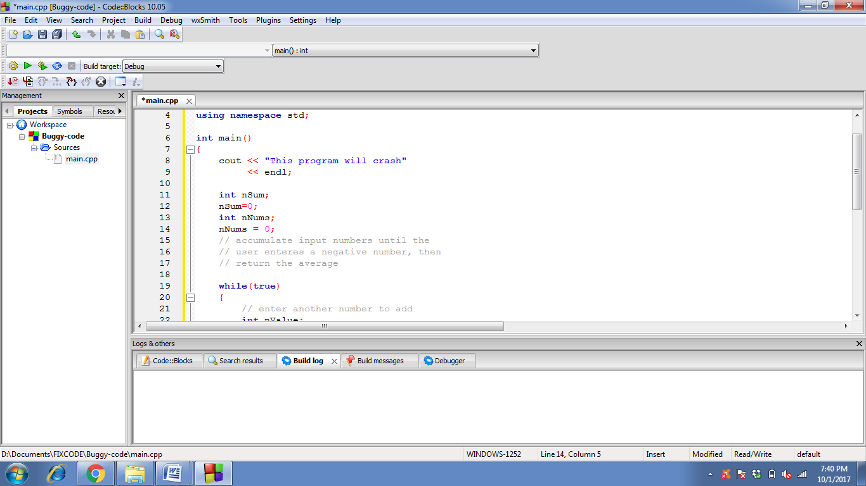

**PRECAUTION :**

To avoid garbage value.

# Correction #3:

General input validation code for integers.

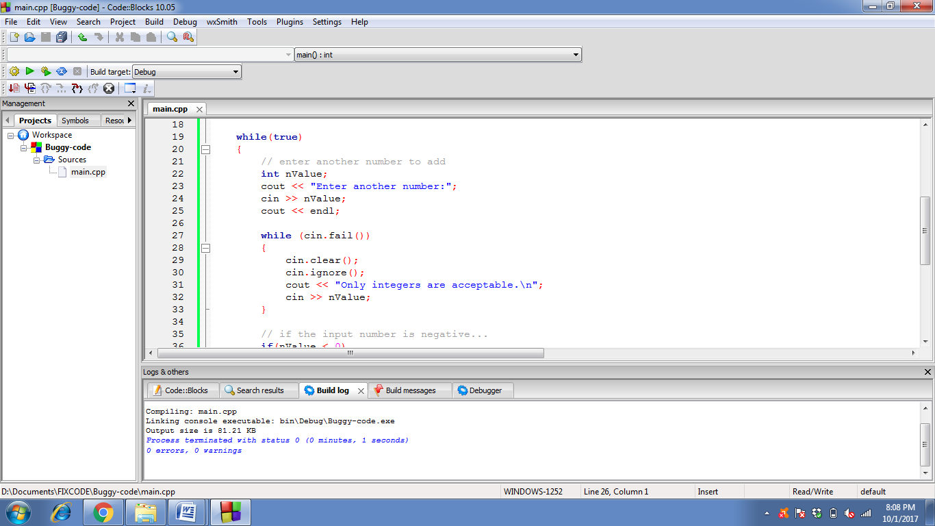

# Correction #4:

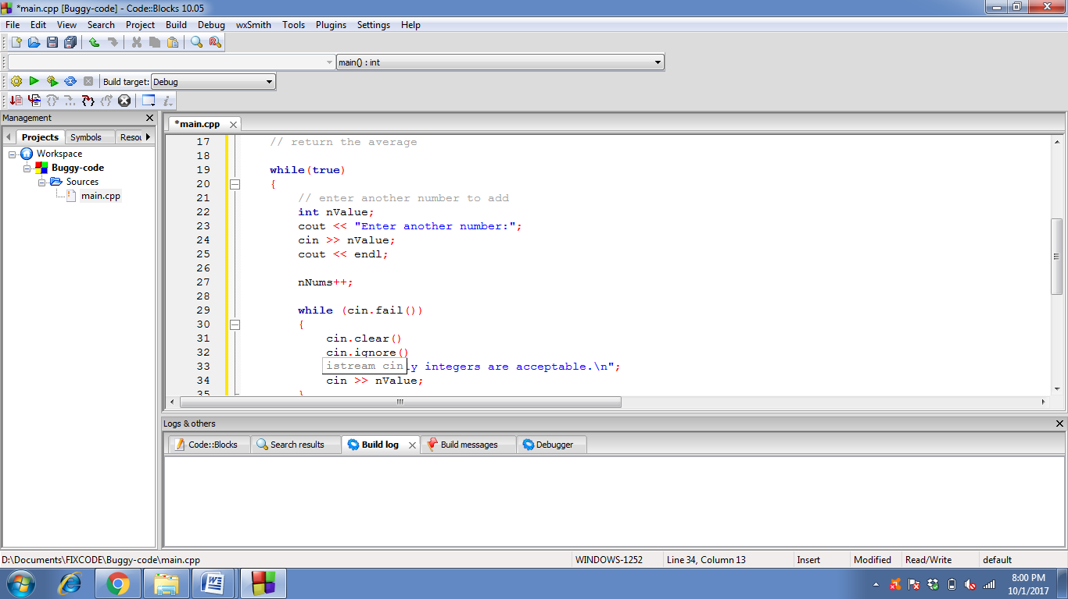

For increament(count ) of number of values entered.

**Average : sum of values(nSum) /no. of values (nNums)**

# Correction # 5:

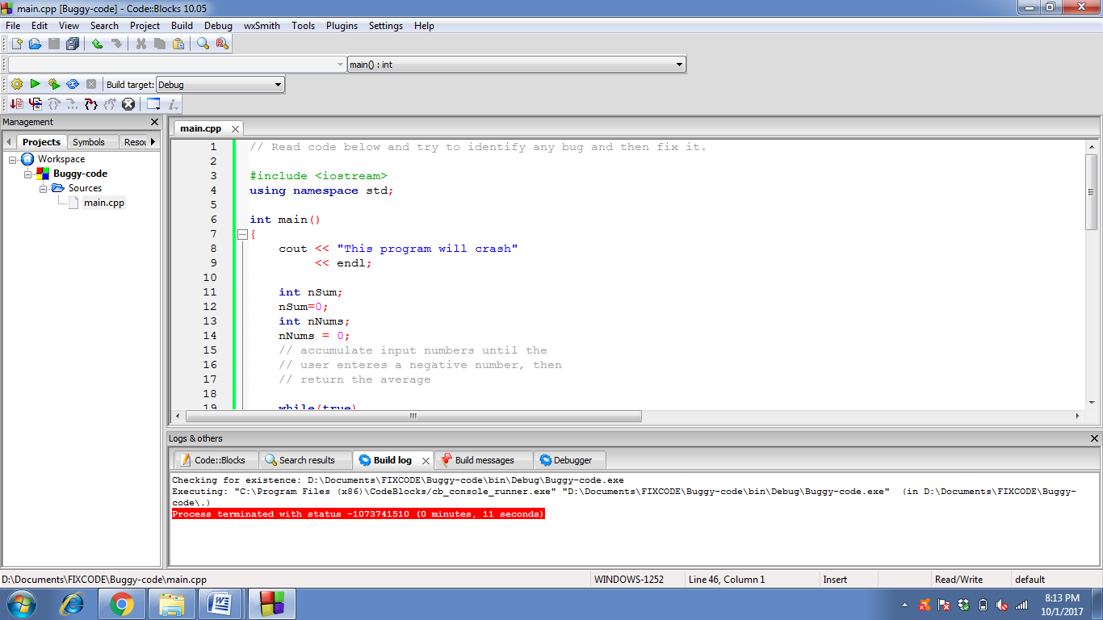

No need of this line as the code works completely fine now

☺

# Final code:

#include <iostream>

using namespace std;

int main()

{

int nSum;

nSum=0;

int nNums;

nNums = 0;

while(true)

{

// enter another number to add

int nValue;

cout << "Enter another number:";

cin >> nValue;

cout << endl;

// input validation for integers

while (cin.fail())

{

cin.clear();

cin.ignore();

cout << "Only integers are acceptable.\n";

cin >> nValue;

}

// if the input number is negative...

if(nValue < 0)

{// ... then output the average

cout << "Average is: "

<< nSum/nNums

<< endl;

break;

}

nNums++; // increament for numbers of value

// not negative, add the value to

// the accumulator

nSum += nValue;

}

cin.ignore(10000, '\n');

return 0;}

# Final Output:

